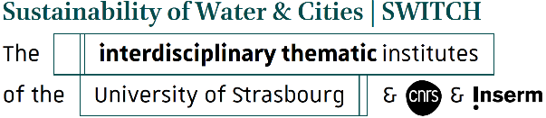

**Funding application   
for participation in a scientific conference**

Academic year 2025/2026

Please complete this form and return it to the following address:[iti-switch-education-contact@unistra.fr](mailto:iti-switch-education-contact@unistra.fr)  
**one month** before the date of the conference for which funding is being requested.

**SURNAME: First name:**

**Email:**

**You are:**

Master's student (specify):

PhD student (specify the affiliated laboratory):

Postdoctoral position (specify the affiliated laboratory):

**SURNAME and first name of your supervising professor:**

**Email:**

**Title of the conference:**

**Date and location of the conference:**

**Website:**

**Your funding needs***Specify the nature and amount of the expenses for which you are applying to ITI Switch (registration, travel, etc.).*

**Have you already received assistance from ITI Switch?** YES  NO

**If yes, specify the date, purpose and amount granted:**

**Name and signature**: Supervising professor or thesis supervisor

**Signature:** Student/PhD student