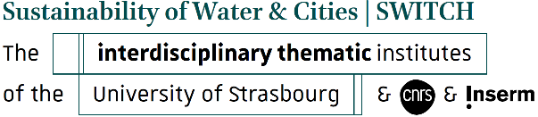

Funding application
for participation in a scientific conference
Academic year 2025/2026

Please complete this form and return it to the following address: iti-switch-education-contact@unistra.fr
one month before the date of the conference for which funding is being requested.

SURNAME: First name:
Email:
You are:
☐ Master's student (specify):
☐ PhD student (specify the affiliated laboratory):
☐ Postdoctoral position (specify the affiliated laboratory):

SURNAME and first name of your supervising professor:
Email:

Title of the conference:
Date and location of the conference:
Website:

Your funding needs
Specify the nature and amount of the expenses for which you are applying to ITI Switch (registration, travel, etc.).

Have you already received assistance from ITI Switch? ☐ YES ☐ NO
If yes, specify the date, purpose and amount granted:
Name and signature: Supervising professor or thesis supervisor
Signature: Student/PhD student

